**System Requirement Specification for Commercial**

***<TravelOne>***

Document Revisions 1

Project Approvals 1

Project Stakeholders 2

1. Requirement Name 2

2. Priority 2

3. Description & Basic Flow 2

3.1. Introduction of Business Requirement 2

3.2. Scope 2

3.3. Out of Scope 2

4. Detailed Scope 2

4.1. Workflow 3

4.2. GUI Interfaces and Screen shots 3

4.3. Biz Rules 3

4.4. Validations 3

5. Process Diagram 3

6. Integrations Required 3

6.1. List of API integration required 3

6.2. API specifications (Credentials, UI matrix, SOAP/Postman Collection) 3

6.3. Field Mapping 3

7. Non-Functional Requirements (NFR) 3

8. Test Scenarios 3

9. Impact Analysis Check list 3

9.1. Module Impacted 3

9.2. Dependent Modules if any 3

# **Document Revisions**

|  |  |  |  |
| --- | --- | --- | --- |
| **Date** | **Version Number** | **Document Details** | **SRS by** |
| 16Apr2024 | V1.0 | New | Ancilla Dsouza |
| 21Jun2024 | V1.1 | UI Updation | Ancilla Dsouza |

# **Project Approvals**

|  |  |  |
| --- | --- | --- |
| **Role** | **Name** | **BRS Approved Date** |
| BRS by | Ancilla Dsouza | 01Feb2024 |
| BRS 1st Viewed by | Bhavani Aiyer | 16Mar2024 |
| BRS Approved By | Jasneet Madan | 16Apr2024 |
|  |  |  |

# **Project Stakeholders**

|  |  |  |
| --- | --- | --- |
| **Role** | **Name** |  |
| **Primary Stakeholder** | **Bhavani Aiyer** |  |
| **Secondary Stakeholder** | **Jasneet Madan** |  |
| **Escalation** |  |  |
| **UX Manager** |  |  |
| **Developer** |  |  |
| **Document Author** |  |  |
| **Test Designed by** |  |  |
| **Test Executed by** |  |  |

# **Requirement Name :** Corporate Commercial

# **Priority:** High

# **Description & Basic Flow**

# **Introduction of Business Requirement**

After the client win, the Sales team approaches Implementation team to complete the Corporate On-boarding process in which the Mastering team completes the Corporate On-Boarding procedure in iBook where in creates the Group, Company & Sub Companies.Commercials are created under the Group

# **Scope**

* + 1. Retrieve Corporate
    2. Create New Commercials
    3. Modify existing Commercials
    4. Copy Commercials
    5. Search by Company
    6. Switch Status – Activate /Deactivate
    7. View Commercials
    8. Upload Commercials through excel for New & existing
    9. Close Form
    10. Reset form
    11. Save Draft
    12. Submit
    13. Maintain Audit trail
    14. Transaction Processing

# **Out of Scope**

Not Applicable

# **Detailed Scope**

* + 1. **Retrieve Corporate**
* Login to TravelOne
* Retrieve Group or Company
* Click ‘Configuration’ -->Commercial Configuration
* Select ‘Commercial Applicable on’ (Either Group or Company)

Screen 1: Search Corp

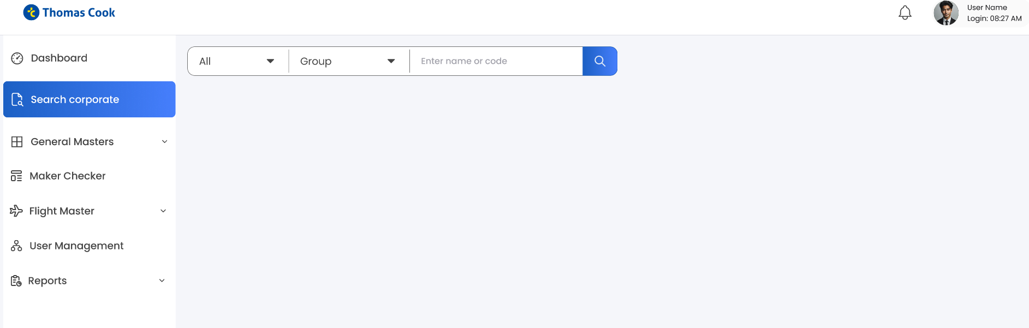

Screen 2: Corporate Search Result

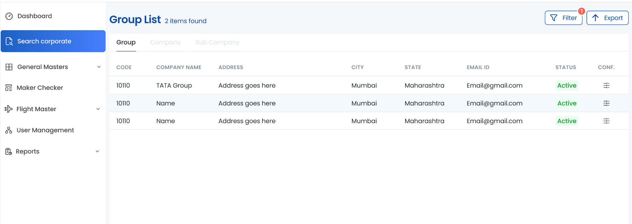

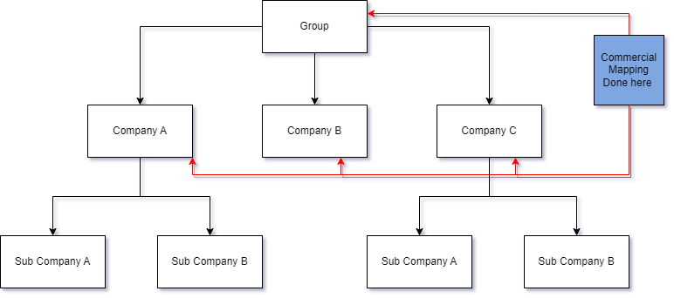

* + 1. **Commercial Configuration: Landing Page**
       1. Upon clicking on ‘Commercial’, the page displays ‘Commercial’ section, which is divided product wise.
       2. Commercial Section shall have all the commercial that should be Configured to manage the Booking Portal
       3. The list of all data fields items available in Separate Excel file. Given snapshot below only for reference purpose
       4. COMMERCIAL’ Tab to do the commercial mapping.

Ref : [SRS-Commercial-DataFeilds.xlsx](https://tcgcapps-my.sharepoint.com/:x:/r/personal/bhasinsrk_thomascook_in/Documents/ASTRA2.0/SRS/SRS_Corp_CommercialConfiguration/SRS-Commercial-DataFeilds.xlsx?d=w4984289d705242398486690efaa98896&csf=1&web=1&e=YK7bzL)

* + - 1. The Commercial entered /updated in the page should be latched to the selected Group or Company

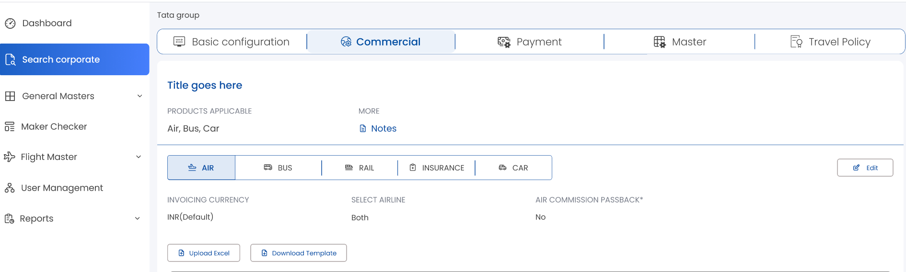

* + 1. **Modify existing Commercials**

Should be able to edit commercials on the UI & bulk upload through excel upload

User Shall click on ‘Edit’

Fields shall be available to edit

User shall modify the required fields & click on ‘Save’ and ‘Submit for Approval’

The Modified details shall go for maker checker approval

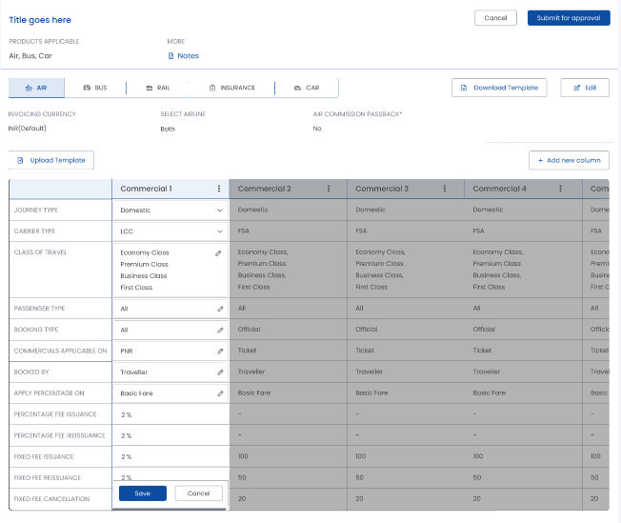

* + 1. **Copy Commercials**

Commercials can be copied from one company to another company within the same group with multi select option**.**

* + 1. **Search by Company**

User should be able to search company to view the commercials

* + 1. **View Commercials**

User should be able to only View commercials. This is user role-based functionality. When the user lands on the commercial page, it will be a view screen.

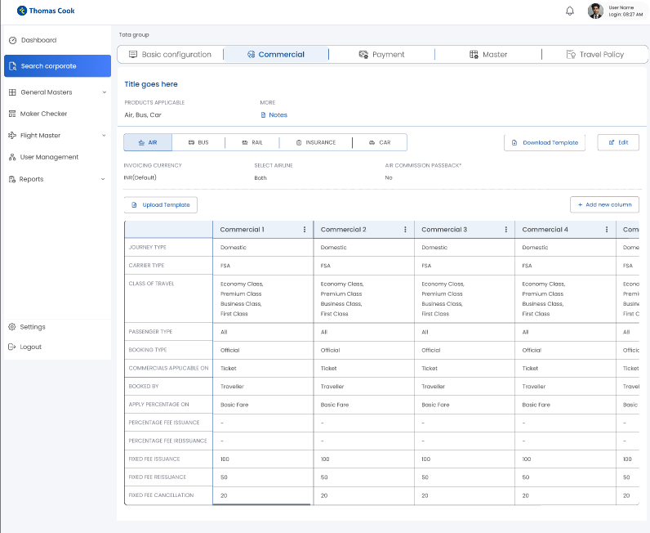

* + 1. **Upload Commercials through excel for New & existing**

User shall download commercial template from the UI

Fill /Modify relevant details in the excel file & upload in TravelOne

Details uploaded shall go to maker checker approval

Post approval data shall get updated in master

* + 1. **Add New Column**

Below is the Screen shot for add new column in the commercial

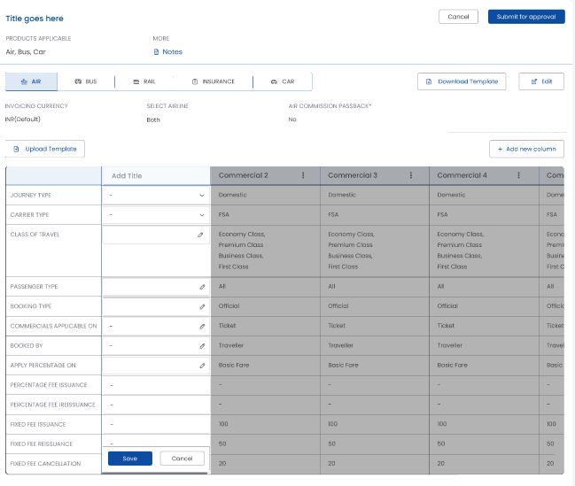

* + 1. **Duplicate Column:**

In this a duplicate column shall be created and edited and then it shall be sent for approval

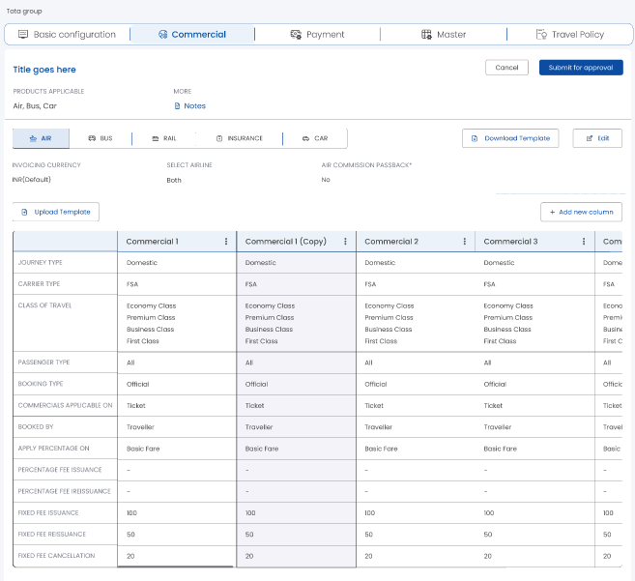

* + 1. **Delete & Rename Option**

1. Delete: There shall be a delete option of the column, which can delete the commercial.
2. Rename : The name of the commercial column can be changed.

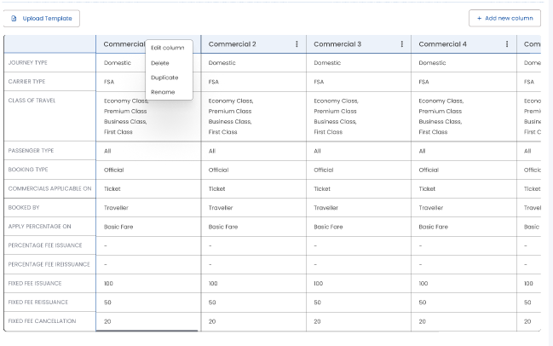

* + 1. **Close Form**

Ref: [Masters-FunctionButtons.xlsx](https://tcgcapps-my.sharepoint.com/:x:/r/personal/bhasinsrk_thomascook_in/Documents/ASTRA2.0/SRS/SRS-All%20Masters/Masters-FunctionButtons.xlsx?d=wc381f9572dd042d7ad5ff497cf8a8dc2&csf=1&web=1&e=MAsrta)

* + 1. **Reset form**

Ref: [Masters-FunctionButtons.xlsx](https://tcgcapps-my.sharepoint.com/:x:/r/personal/bhasinsrk_thomascook_in/Documents/ASTRA2.0/SRS/SRS-All%20Masters/Masters-FunctionButtons.xlsx?d=wc381f9572dd042d7ad5ff497cf8a8dc2&csf=1&web=1&e=MAsrta)

* + 1. **Save Draft**

Ref: [Masters-FunctionButtons.xlsx](https://tcgcapps-my.sharepoint.com/:x:/r/personal/bhasinsrk_thomascook_in/Documents/ASTRA2.0/SRS/SRS-All%20Masters/Masters-FunctionButtons.xlsx?d=wc381f9572dd042d7ad5ff497cf8a8dc2&csf=1&web=1&e=MAsrta)

* + 1. **Submit**

Ref: [Masters-FunctionButtons.xlsx](https://tcgcapps-my.sharepoint.com/:x:/r/personal/bhasinsrk_thomascook_in/Documents/ASTRA2.0/SRS/SRS-All%20Masters/Masters-FunctionButtons.xlsx?d=wc381f9572dd042d7ad5ff497cf8a8dc2&csf=1&web=1&e=MAsrta)

* + 1. **Maintain Audit trail**

The System should maintain the versioning, User details & all other details in audit trails

Ref**:** [AuditTrail-Masters.xlsx](https://tcgcapps-my.sharepoint.com/:x:/r/personal/bhasinsrk_thomascook_in/Documents/ASTRA2.0/SRS/SRS-All%20Masters/AuditTrail-Masters.xlsx?d=wb50b913dc48445b2a92aada49d26187f&csf=1&web=1&e=2BT8jG)

* + 1. **Transaction Processing**

This refers to the process of handling & completing a business transaction for all products.

# **Workflow**

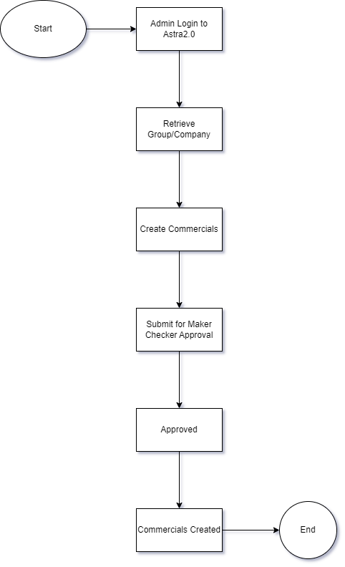

# **GUI Interfaces and Screen shots**

Commercials Config Screen

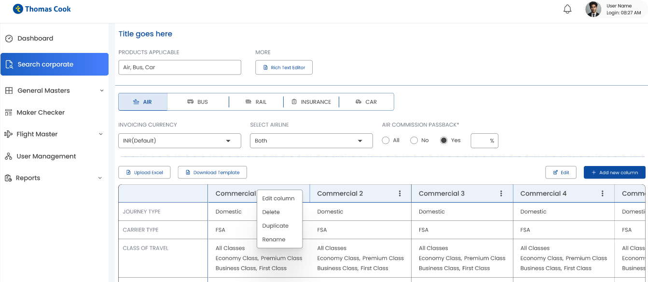

All Fields

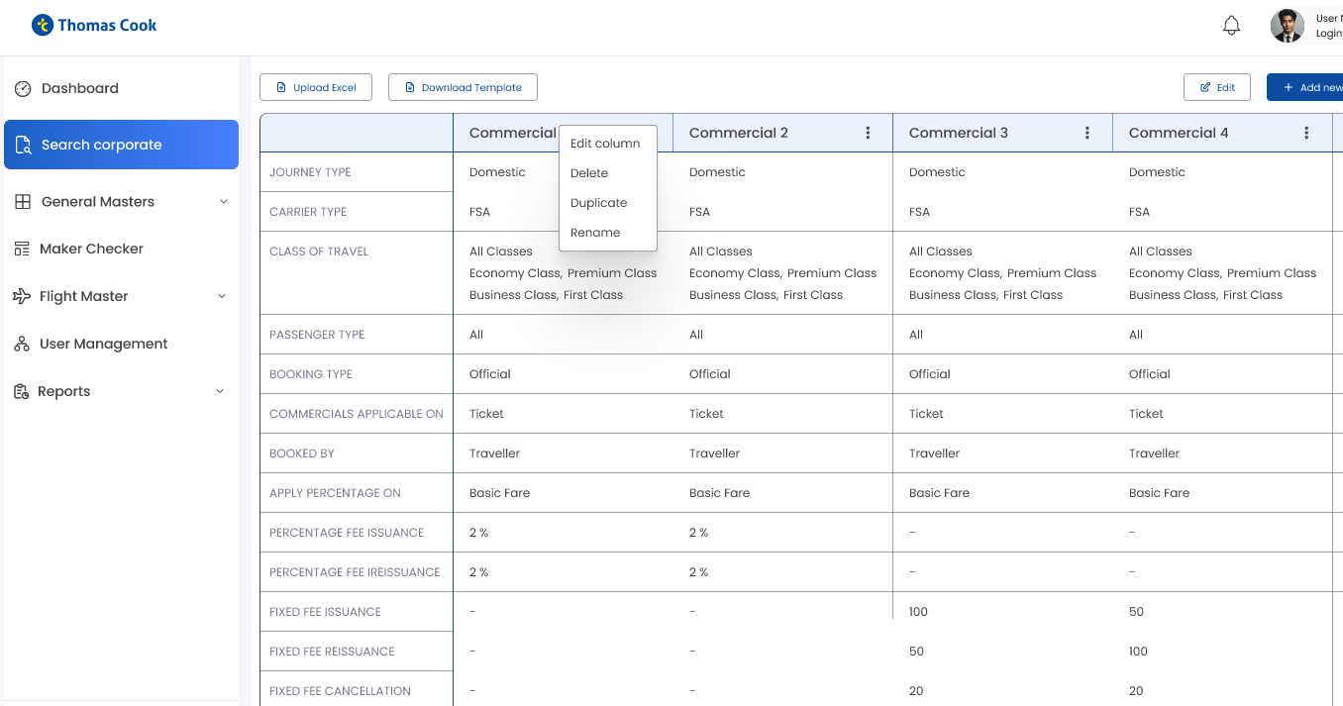

Submit for approval

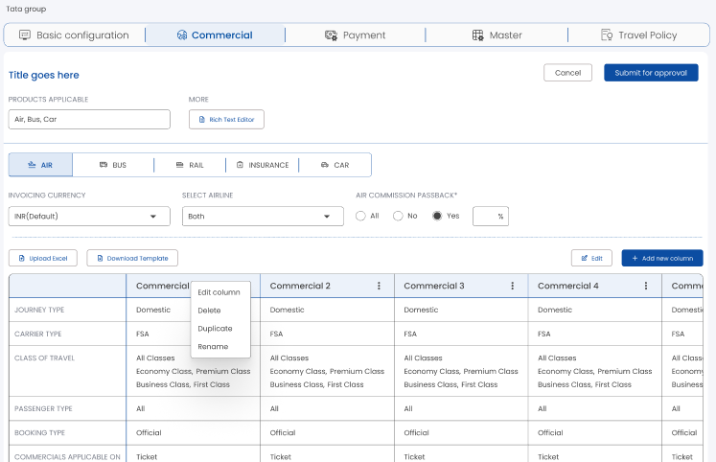

# **Biz Rules**

Ref : [Business Rules & Validations.xlsx](https://tcgcapps-my.sharepoint.com/:x:/r/personal/bhasinsrk_thomascook_in/Documents/ASTRA2.0/SRS/SRS_Corp_CommercialConfiguration/Business%20Rules%20%26%20Validations.xlsx?d=wd4a989ca54e841988319d013033280ea&csf=1&web=1&e=gwZDAN)

# **Validations**

Ref : [Business Rules & Validations.xlsx](https://tcgcapps-my.sharepoint.com/:x:/r/personal/bhasinsrk_thomascook_in/Documents/ASTRA2.0/SRS/SRS_Corp_CommercialConfiguration/Business%20Rules%20%26%20Validations.xlsx?d=wd4a989ca54e841988319d013033280ea&csf=1&web=1&e=gwZDAN)

# **Process Diagram**

Covered in detailed flow section above

# **Integrations Required**

Not Applicable

# **List of API integration required**

Not Applicable

# **API specifications (Credentials, UI matrix, SOAP/Postman Collection)**

Not Applicable

# **Field Mapping**

Covered in detailed scope ref 4.1.2

# **Non-Functional Requirements (NFR)**

Ref: [NFR.xlsx](https://tcgcapps-my.sharepoint.com/:x:/r/personal/bhasinsrk_thomascook_in/Documents/ASTRA2.0/SRS/SRS_Corp_CommercialConfiguration/NFR.xlsx?d=w1a66554d77f6497a9418b058ca59b579&csf=1&web=1&e=euwmxb)

# **Test Scenarios**

Ref : [Test Scenarios_Corporate Commercials.xlsx](https://tcgcapps-my.sharepoint.com/:x:/r/personal/bhasinsrk_thomascook_in/Documents/ASTRA2.0/SRS/SRS_Corp_CommercialConfiguration/Test%20Scenarios_Corporate%20Commercials.xlsx?d=wb5d27e9997374f22ad64087e68799ce8&csf=1&web=1&e=Xx7g8B)

# **Impact Analysis Check list**

Not Applicable

# **Module Impacted**

Not Applicable

# **Dependent Modules if any**

Not Applicable

**-END-**